19.51:
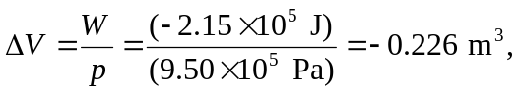

with the negative sign indicating a decrease in volume.

